

**Sending a message through Amazon Simple Notification Service(SNS)**

Step 1: Open SNS dashboard

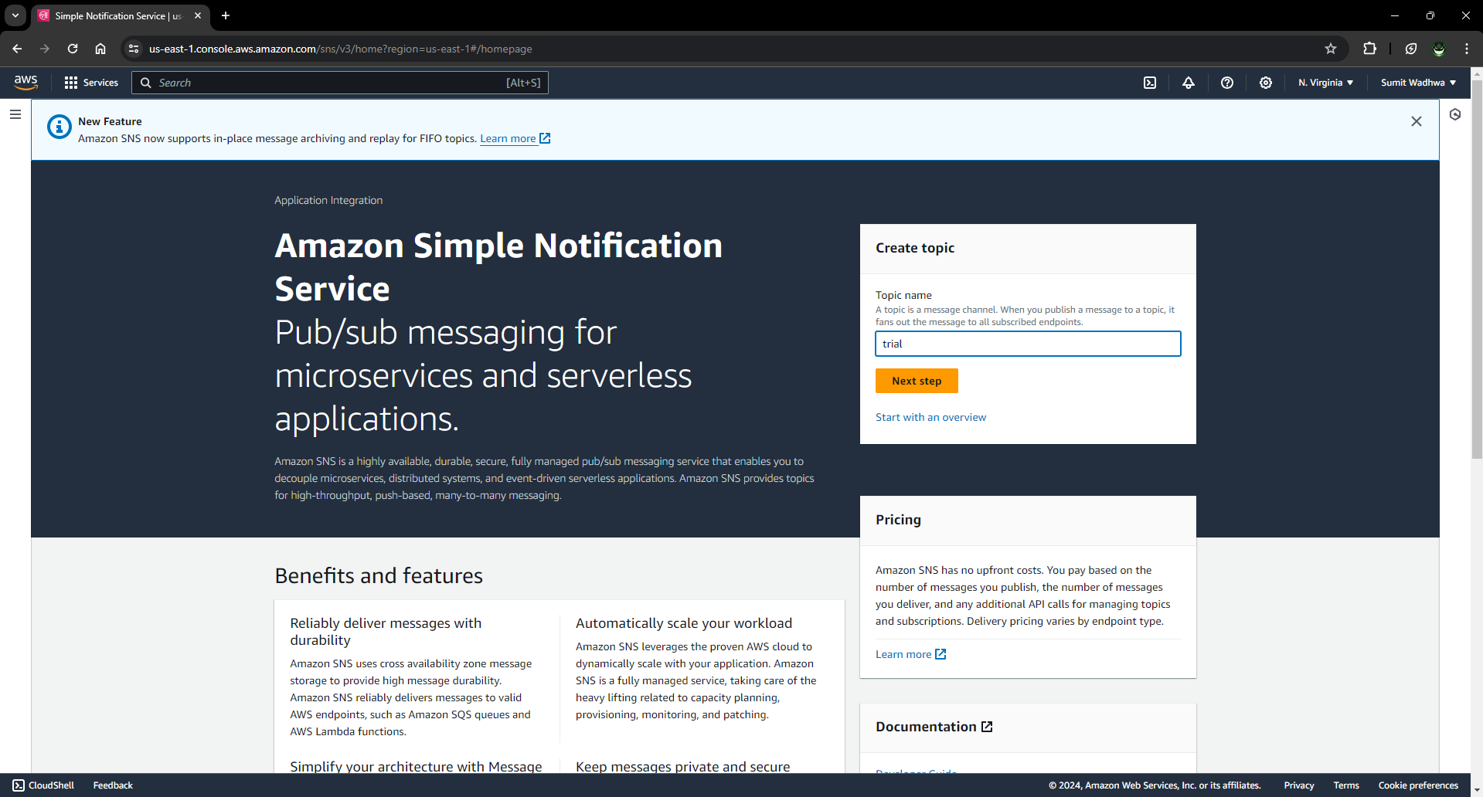

Step 2: Create a topic by selecting type and name

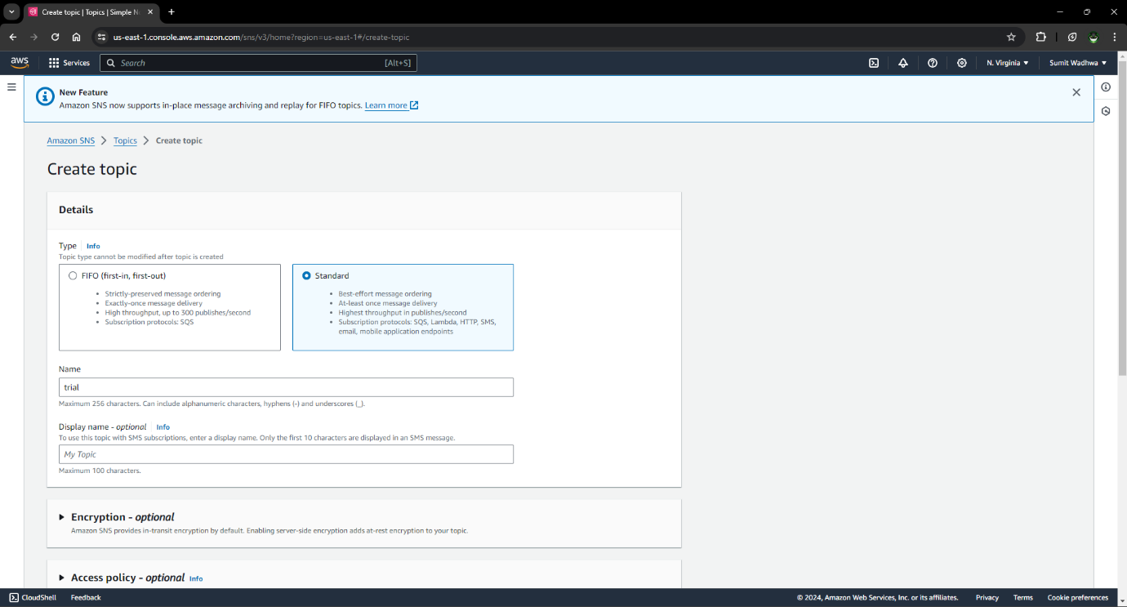

Step 3: Topic is created

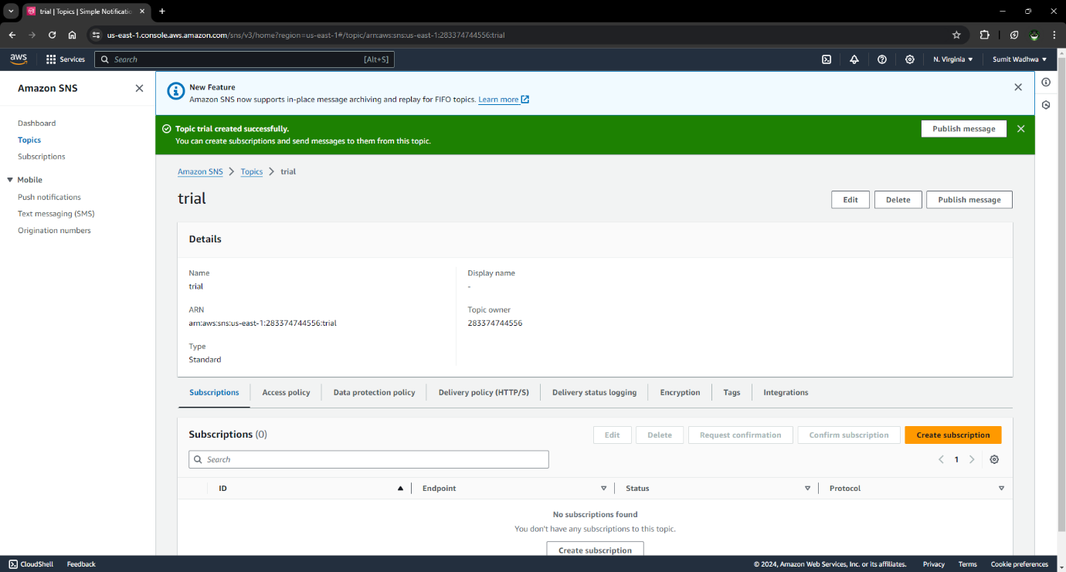

Step 4: Create a subscription by adding ARN name, choosing protocol and entering endpoint

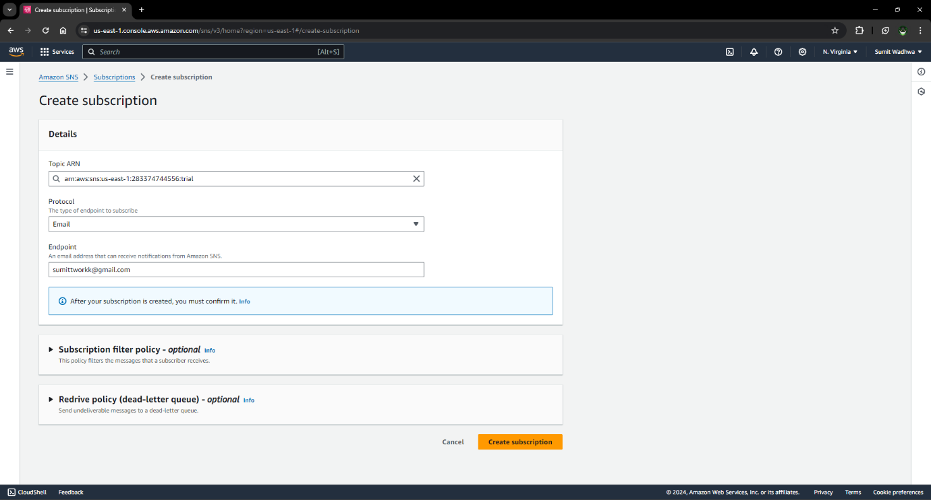

Step 5: Check for message and confirm the subscription

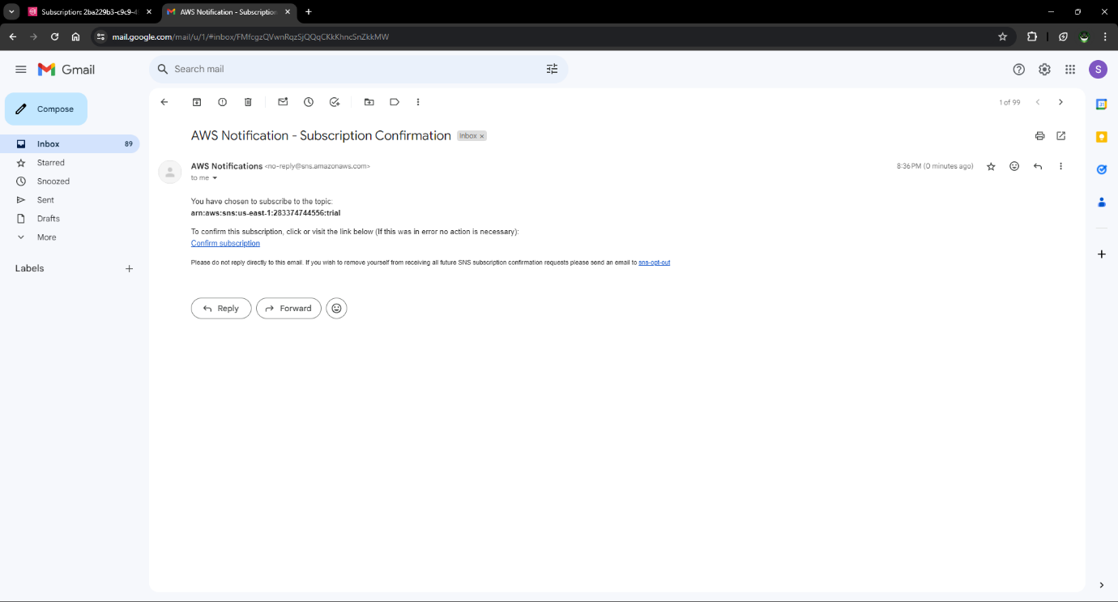

Step 6: Check if subscription is confirmed

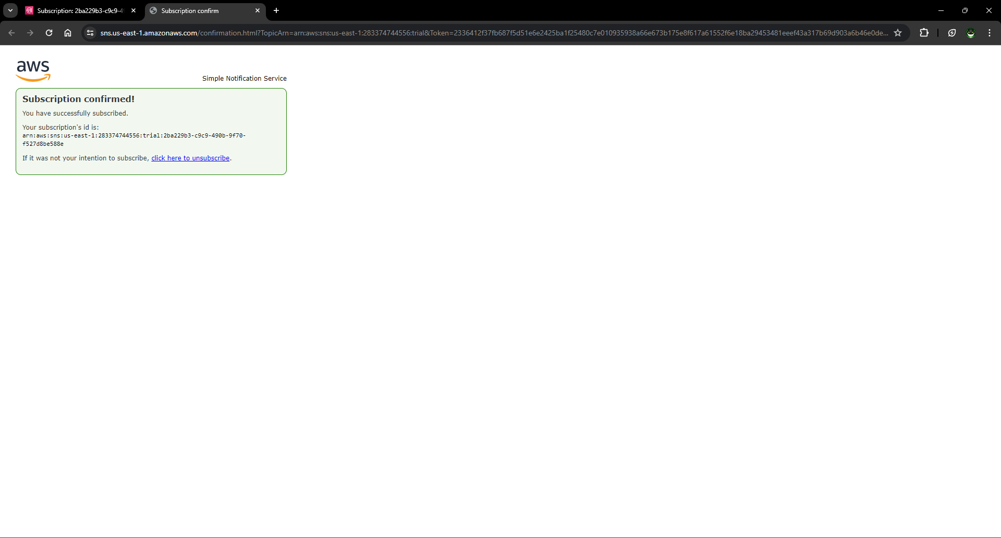

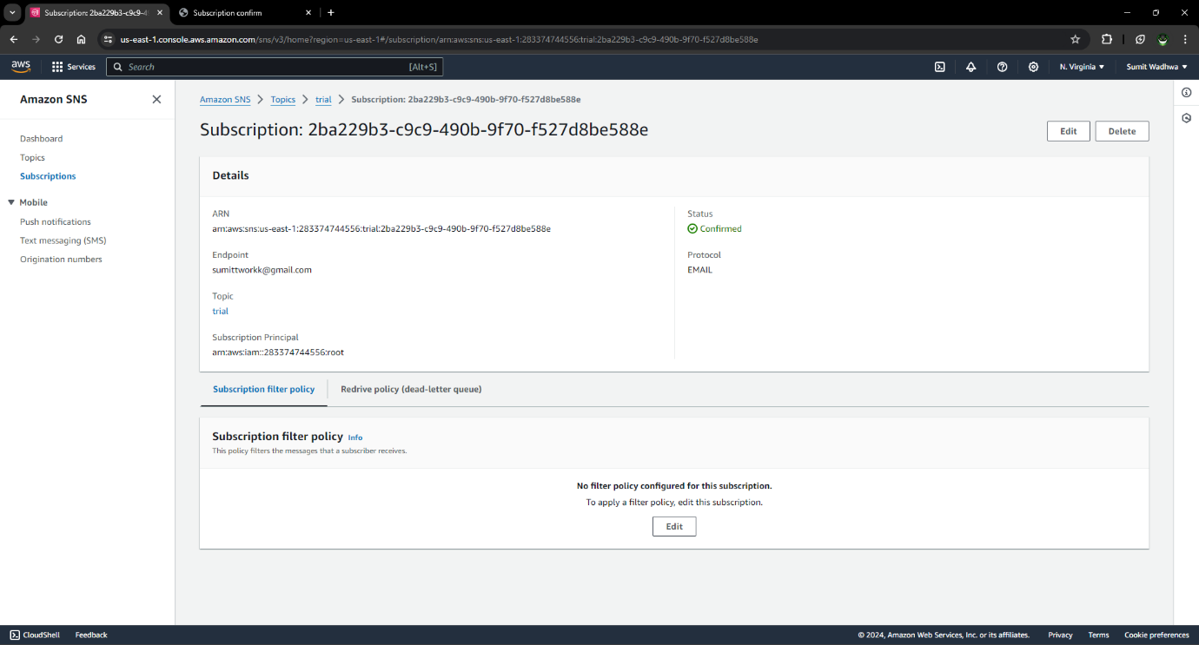

Step 7: Publish the message

* Enter time to live
* Select message structure
* Write the message

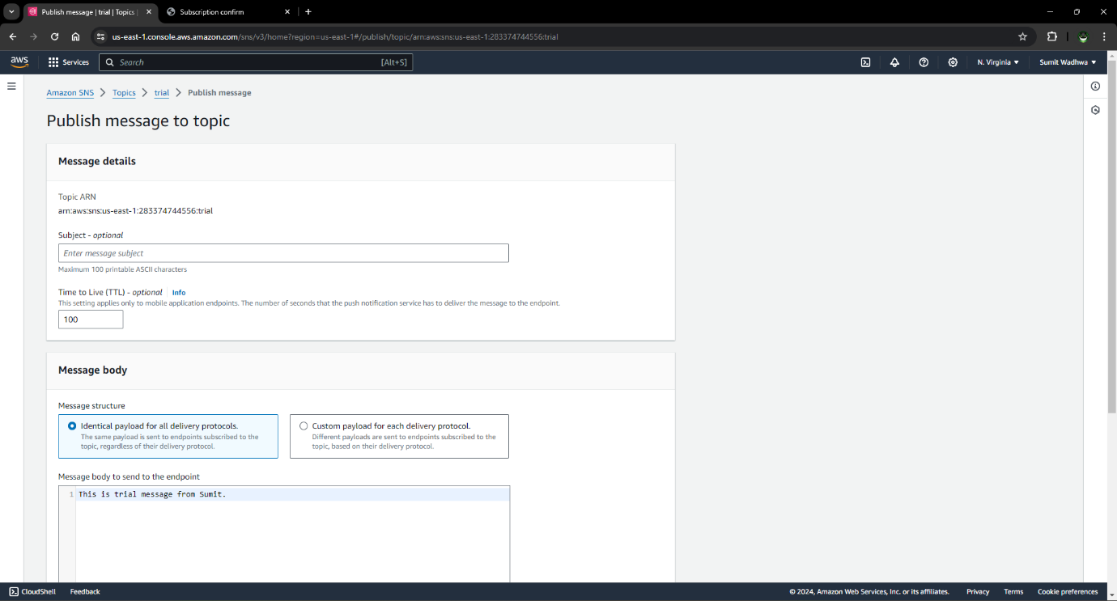

Step 8: Check the message

